# Instructions for Creating a new Sketch

**Create the New Sketch Settings**

1. Add **simulator debug** fileto sketch**:** #include <SimulateDebug.h>
2. Remove **Other Flags** from **C Compiler -> Miscellaneous** for **All Configurations**:

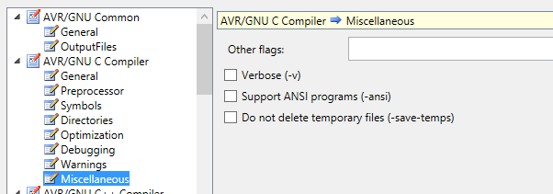

1. Add following **Other Flags** to **C++ Compiler -> Miscellaneous** for **All Configurations**:
   1. -std=gnu++14 -pedantic

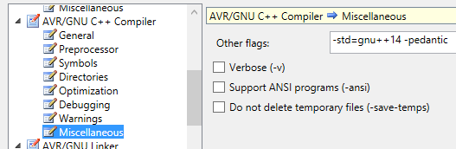

1. Add following **Include Paths** to **C++ Compiler -> Directories** for **All Configurations.** Also Add additional include paths for the code libraries needed for the sketch.

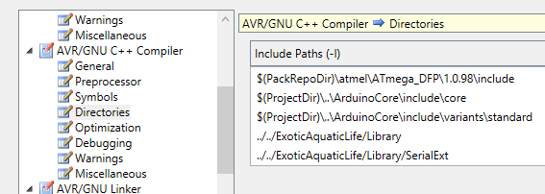

1. Add a **Post-Build event** to invoke upload to Arduino on **Release Configuration**:
   1. Change **port** appropriately.
2. Add **references** to **AdruinoCore** and **ExoticEquaticLife** Libraries:
   1. Change **cppproj** to following**:**

<ProjectReference Include="..\ExoticAquaticLifeLib\ExoticAquaticLife\ExoticAquaticLife.cppproj">

To

<ProjectReference Include="..\ExoticAquaticLife\ExoticAquaticLife.cppproj">

**ExoticAquaticLife Settings (for reference)**

1. Added **F_CPU** to **C++ Compiler -> Symbols** for **All Configurations**

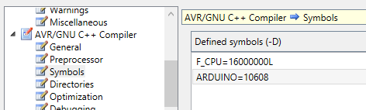

1. Added following **Other Flags** to **C++ Compiler -> Miscellaneous** for **All Configurations**:
   1. -std=gnu++14 -pedantic



1. Added following **Include Paths** to **C++ Compiler -> Directories** for **All Configurations**

